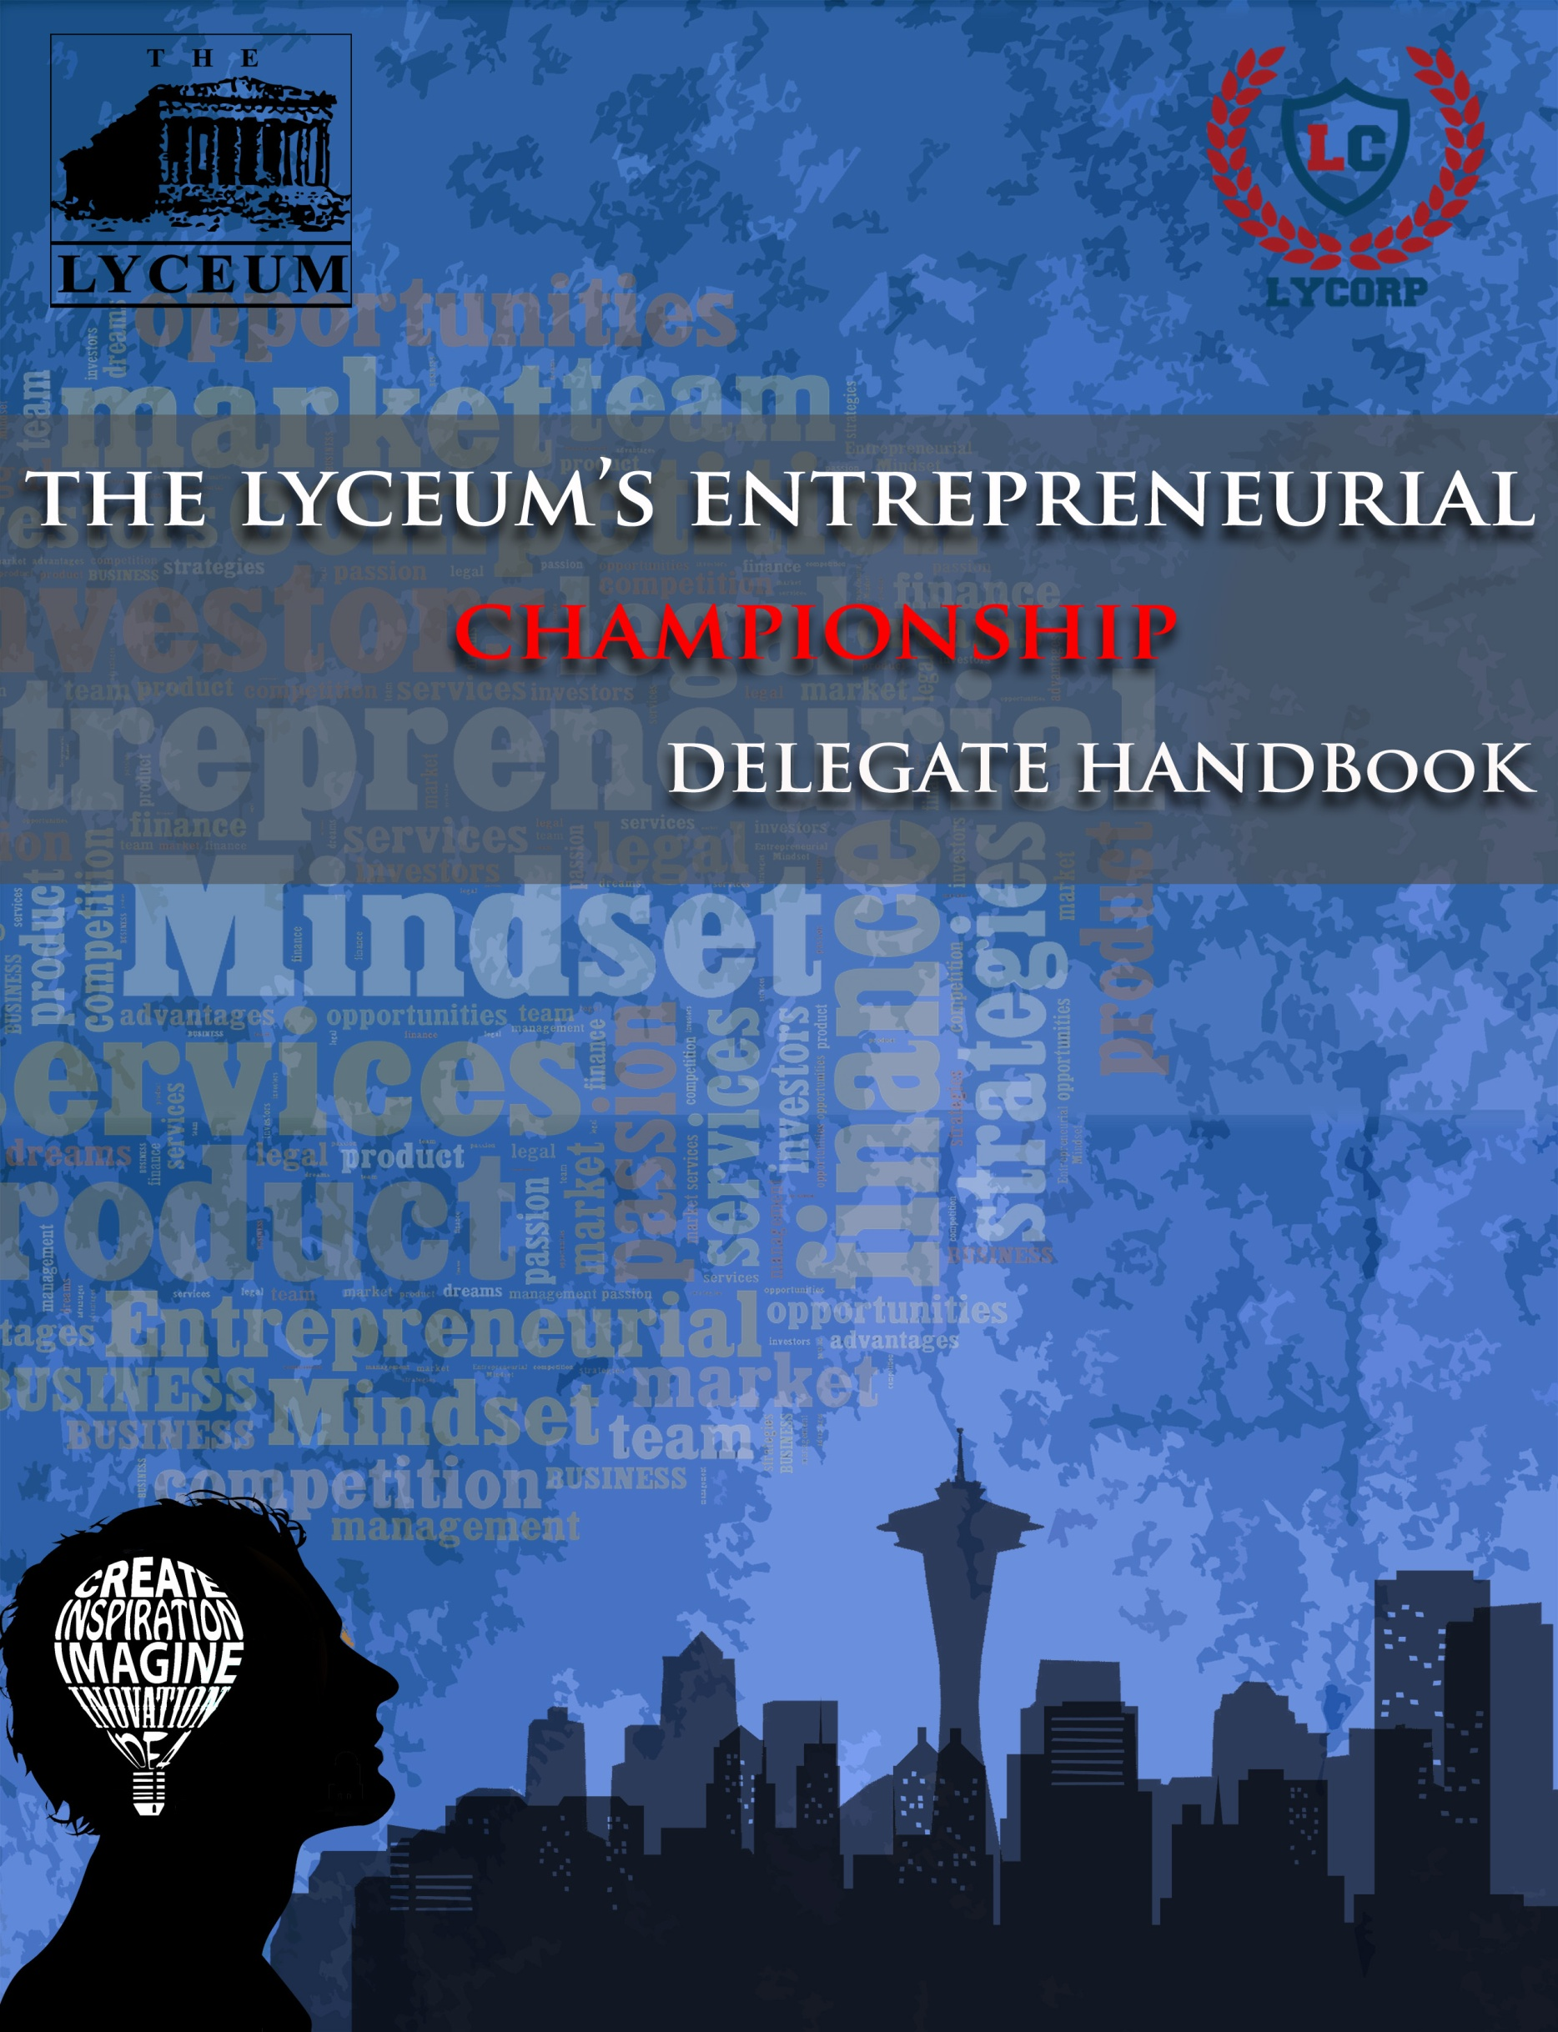

**About TLEC ’16**

The Lyceum is an A Level Institution established in August 1987 to meet a growing demand for quality Cambridge International Examinations education. Over the past 28 years, we have worked to create an ecosystem, which facilitates the preparation of our youth ‘for every future’. The School is greatly committed to a holistic approach to education, which fosters positive personality traits and enables our students to develop real world knowledge. The Lyceum Corporate Society (LyCorp) is an extension of the Lyceum’s vision, dedicated to promoting future leaders and entrepreneurs in social and corporate enterprises.

The society was founded six years ago in 2009, and since then, has developed into one of the biggest and most active societies of the school. It aims to promote entrepreneurship skills among students and give you an insight into the cutthroat atmosphere of today’s markets. It aims to enhance your public speaking and management skills and develop professionalism in all entrepreneurial endeavors.

One of this year’s biggest events organized by LyCorp is the Lyceum Entrepreneurial Championship (TLEC) 2016. In its third year LyCorp is extending the invitation to schools and colleges not only around Karachi but also all over the country. We believe that by taking part in this event we can nurture young entrepreneurs and provide them with the exposure needed. Introduce your concept to renowned entrepreneurs, prune and develop your idea under their mentorship, and get the applause and acknowledgment you deserve.

This document contains important details about TLEC. Please go through the entire document thoroughly as it will assist you in preparing for the championship.

**Linkages**

**Platinum Sponsor**



**Vision**

National Bank of Pakistan is one of the largest commercial banks operating in Pakistan. It has redefined its role and has moved from a public sector organization into a modern commercial bank. The bank’s vision is to develop and nurture the country's small and medium enterprises and at the same time also fulfill its social responsibilities as a corporate citizen.

**Gold Sponsor**



**Vision**

Monet is Pakistan’s first and neutral independent payment services provider with solutions in prepaid cards, mobile finance, billing and service aggregation space. Their vision is to establish mobile money network by collaboration between banks, telecommunications, merchants and distribution networks.

**Silver Sponsors**

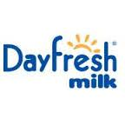



**Business Events**

**VENTURE DRIVE**

Venture Drive will put your innovative skills to the test. For this business event, teams are required to come up with a business idea. You will be required to dig deep and bring forward a new and original idea that works to bring about a mind shift and guides concrete actions towards a sustainable society. In a nutshell, Venture Drive will ask you to take an idea and discuss its high-potential commercial opportunity and sustainability, gather resources such as distributors and capital, figure out how to sell and market your idea, and manage rapid growth with the use of various available resources present in the modern age.

**Round 1: Elevator Pitch**

An elevator pitch is a short summary used to quickly and simply defines a profession, product, service, organization or event and its value proposition. In this round teams will be given 90 seconds to deliver an effective elevator pitch about their proposed business idea, which will include characteristics, unique selling point and innovation of the business idea put forward to the judges. However, teams are advised to keep their pitches concise and to the point, in addition to being captivating. The main aim of such pitches is to give potential investors a general idea of what the business or product is about.

**Round 2: Business Model Canvas**

A Business Model Canvas is a great way to put your ideas on paper before starting your entrepreneurial journey. Round 2 will provide a platform to present and discuss the operations of their business on a Business Model Canvas (BMC), to a panel of judges. This round is more interactive as compared to the others. The focus would be on teams’ business model innovation and organization more than anything else, and participants are expected to describe, design and explain their business model in thorough detail. A BMC is a visual chart with elements describing a firm's value proposition, infrastructure, customers, and finances. They have to highlight details about some of the following aspects of their business:

1. Customer segments (all people and organizations who you are creating value for) Channels to reach customers (the way you are interacting with customers and delivering value)
2. Revenue streams you generate
3. Key Resources
4. Key Activities you require to create value
5. Key Partners
6. Cost Structure (Revenue Sources, Price policy, Start-Up costs)

Teams must use the Business Canvas given on the link stated below:

<https://strategyzer.com/canvas>

**BRAND RUSH**

**Round 1: Brand Rush**

Here, you will be given stalls to set up and represent the brands allocated you to beforehand. You will be looking into the Nitti gritty of marketing plans and strategies and will have to think of how you can magnet the crowd towards yourself. Brand Rush is based on testing the marketing and advertising skills of the participants. They will be judged on how efficiently and innovatively they are able to convey their message given the constraints.

If you think that you could sell anything and everything, Brand Rush is the perfect event for you.

* In this round each of the teams will be allotted a brand, which they will present in the form of a stall in the Brand Court on TLEC ‘16.
* All mediums will be used to market the brand such as jingles, prints, standees, flyers, posters, new taglines; booklets etc. teams should bring all their promotional material with them.
* Teams will be given one hour and fifteen minutes to set up their stalls which will then be followed by an evaluation round by the judges.

**Round 2: Press Mania**

This is the crisis round. Teams will be given a case study on short notice and will be required to research the issue after which they will be subjected to questions from the press regarding their case study.

Teams will be given a crisis on Friday 6th of February 2015. The crisis will be a real life situation, which was faced by a firm in the real world. Teams will have to come up with new strategies to tackle the issue they are given and present them in the form of a Press Conference.

Each team will give a 120 second long opening statement. This will be followed by questions by the media representatives present. The length of this question answer session depends on the discretion of the judges.

All teams will be required to arrange the promotional material in advance that will be used to decorate the designated stall. Convince the judges why your stall is the best and above all have fun because this is the most fun filled business event at TLEC ‘15

P.S: Unleash the marketing geniuses in you. A little hint in here: Think outside the box. Break creative barriers.

Note: Teams cannot follow the exact same course of action the company they are representing employed. Any teams found guilty of doing this will be immediately disqualified.

**Round 3: Rise From The Grave**

In this challenge, delegates will be given a failed brand. The test requires delegates to research about the brand, determine the causes of its failure and then devise new marketing strategies in order to bring the brand back to life. This round puts your creativity and innovation to test. Hence, study the brand and the failed product well, think out of the box and come up with innovative strategies to revive the product.

Each team will be given 9 minutes to present their brand launch, which will then be followed by a question answer session

It is advised to include the following in your presentation:

* Marketing Strategies
* Target market
* Location
* Launch Event
* Budget

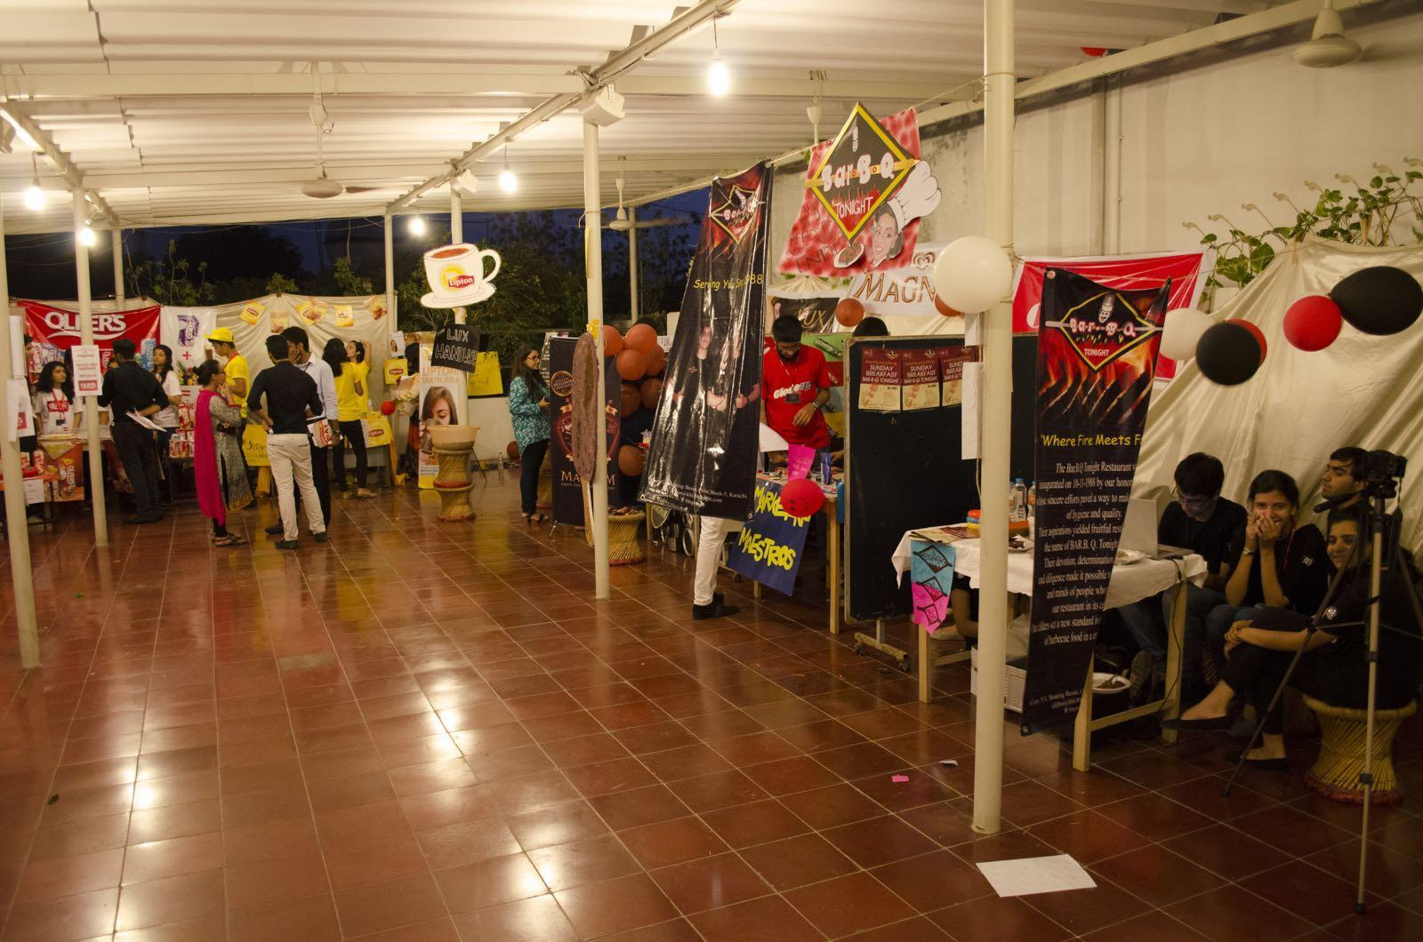

**LIGHTS, CAMERA, ACTION!**

**Round 1: Ad Round**

Teams shall be allotted a product each, for which they will have to make an advertisement. In order to flower creativity, teams will be allowed to pick any theme and any route they wish to take for their ads, and it is upon them to choose their targeted audiences. However, delegates should bear in mind that copyright infringement will result in instant penalization of scores.

It should be noted that no vulgarity, racism, swearing and negative campaigning, or any issue under the same umbrella, would be tolerated

Pertinent details are as follows:

* All the teams will have to make a video advertisement with a maximum duration of 1 minute
* The Products will be assigned to the teams via Email.

All completed ads (accompanied by the name of the team) must be submitted on **Friday 29th January** at the registrations desk in a USB drive.

[TLEC '16](https://www.facebook.com/thelyceumentrepreneurialchampionship)

On the day of the event you are expected to present your advertisements to the judges with an optional explanatory speech, which includes your point of view and reasoning behind the techniques used in the ad.

**Round 2: Integrated Marketing Communications Campaign**

The IMC is simply the integration of multiple marketing disciplines that are deployed to achieve the particular goals of companies. This is done through the development of marketing strategies and creative campaigns as well as the application of promotional methods to reinforce those goals.

Details of this round are as follows:

* Each team will be given 8 minutes to present their IMC, followed by a question and answer session with the judges.
* Each team must consider the following components of the IMC:

1. Print Media
2. Social Media
3. Special Events Campaign
4. Public Relations Campaign

* Each team will be judged on the following parameters:

1. Overall impact of strategies.
2. Distribution of aforementioned components
3. Creativity, Originality, and Innovation of IMC
4. Clarity and relevance of campaign to target market

**SOCIAL INITIATIVE**

Encompassing a profit motive, businesses often ignore the costs that society may incur. Hence, as aspiring entrepreneurs we reckon it to be our responsibility to promote social corporate responsibility initiatives in order to ensure maximum positive impact on society. So if you think you have the urge to combine entrepreneurial skills along with social sustainability then this challenge puts you to test! Thus this is your chance to come up with new ideas and play your part in implementing a positive impact on society.

**Round 1:**   
This round requires you to identify the social problems and propose solutions to counter the societal issue assigned to you. Furthermore, delegates are advised to propose solutions that are:

* Unique and Practical
* Cost Effective and Feasible
* Viable and Sustainable

**Round 2:**

This round requires you to start your own organization and propose a solution to the problem. Each team will be given 5 minutes for the presentation, followed by a brief question and answer session with the judges regarding their proposed business idea.

Each presentation, at minimum, should include:

* Business overview of the solution
* Target market Promotion/Marketing strategy
* Financial prospects of the business

Each team will be judged on the following parameters:

* Relevance of the business idea to the problem.
* Creativity and uniqueness of the business idea.
* Feasibility of the business.
* Financial stability of the business idea in the long run.
* The sustainability of the business in the long run.

**Social Events**

**Qawwali Night**

There’s nothing like a night filled with sufi kalams that stir your soul. The Qawwali Night, on Saturday, 30th January, is the perfect setting for delegates to unwind after the grueling rounds at the competition during the day, and is truly a performance not to be missed considering whom we’ve invited to perform this year!

**Closing Ceremony and Dinner**

Your unforgettable experience at TLEC will also include a themed formal dinner followed by the closing ceremony on Sunday 31st January. You will not only be overwhelmed by the ambiance, décor and cuisine but will be provided with the opportunity to interact and socialize.

**Our Team**

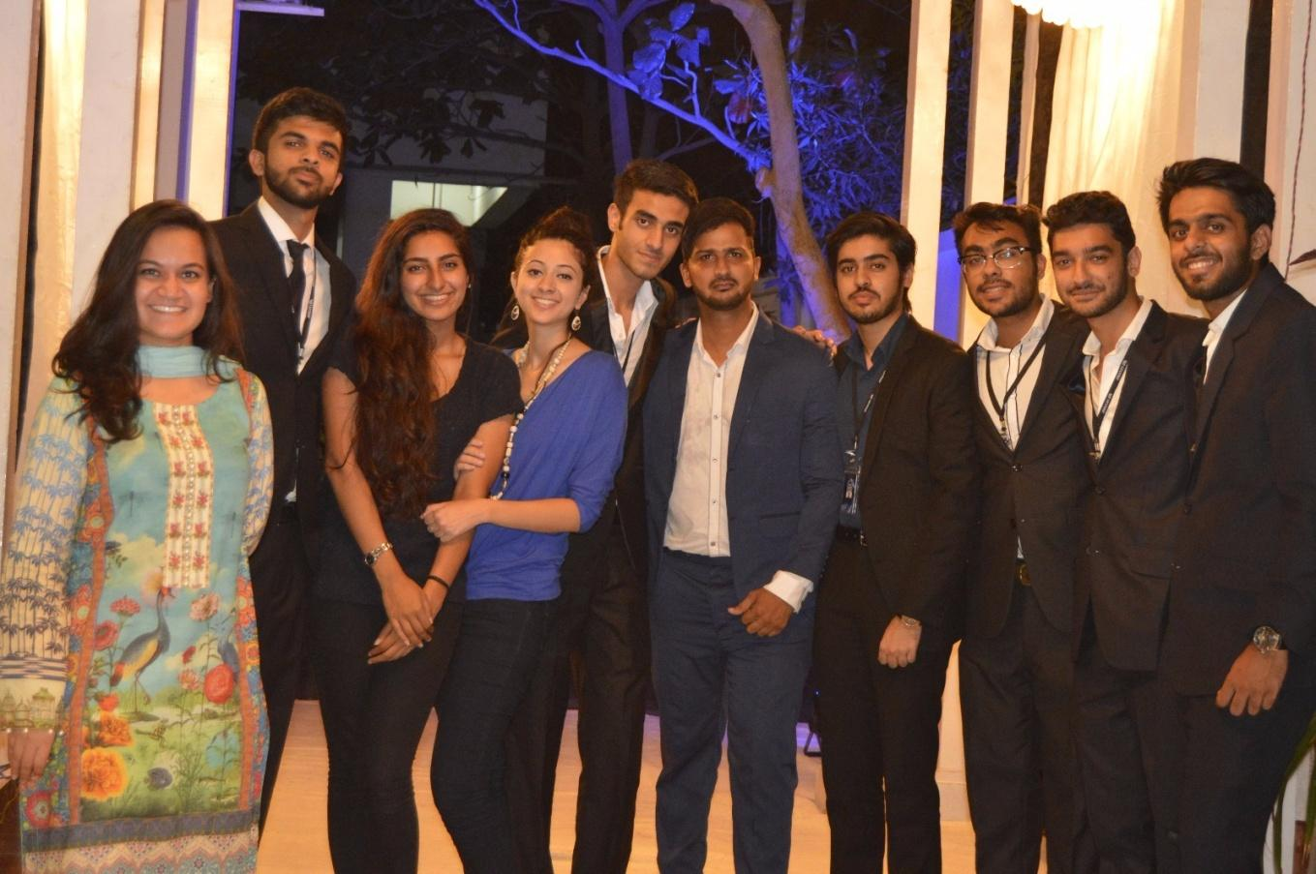

**Itinerary**

|  |  |  |
| --- | --- | --- |
| Day 1 - 29th January  Friday | Event | Reporting Time |
| Registration | 14.00-14.30 |
| Opening Ceremony | 14.30-15.30 |
| Brand Rush | 15.30-19.00 |
| Elevator Pitch | 19.00-21.00 |
| Day 2 - 30th January  Saturday | Lights, Camera, Action | 9.00-11.00 |
| Social Initiative | 11.00-13.30 |
| Lunch Break | 13.30-14.30 |
| Business Model Canvas | 14.30-17.00 |
| Social Event: Qawwali | 18.00-21.00 |
| Day 3 - 31st January  Sunday | Social Initiative (Round 2) | 9.00-11.00 |
| Press Mania | 11.00-14.00 |
| Lunch Break | 14.00-15.00 |
| Integrated Marketing Communications | 15.00-17.00 |
| Rise From The Grave | 17.00-19.00 |
| Closing Ceremony & Dinner | 19.00-21.00 |